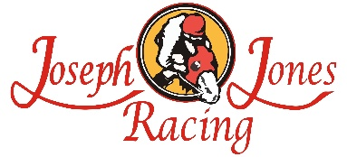
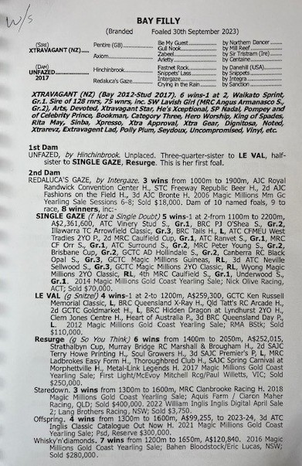
XTRAVAGANT X UNFAZED 2YO FILLY
- 5% SHARE IS $1,310 FEES START 1/5/26 70% AVAILABLE.
- Her dam Unfazed is a ½ sister to Group 1 winner SINGLE GAZE
- Her dam Unfazed is also ½ sister to Group performed LE VAL & Resurge
- Strong Filly who is broken-in & due to have first education prep Feb 26.

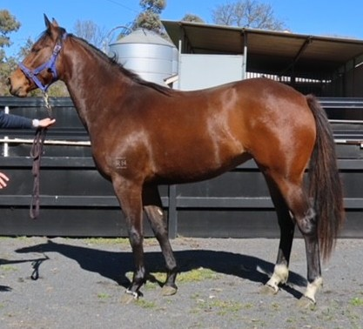
EMAIL ENQUIRIES@JOSEPHJONESRACING.COM.AU
OR PHONE PAUL ON 0414 811 561

