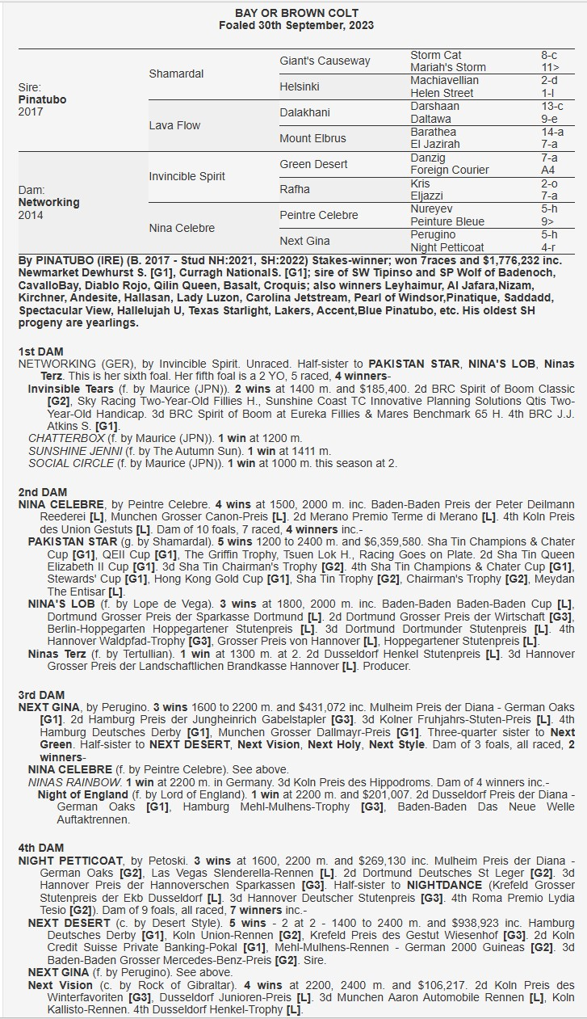

PINATUBO X NETWORKING 2YO Gelding
- 5% SHARE IS $1,990 FEES START 1/5/26 50% AVAILABLE.
- PINATUBO was a champion 2yo in EUROPE inc 6 wins as a 2yo.
- PINATUBO oldest SH progeny are 2yo, already has Group winners in NH
- His dam Networking is a ½ sister to HK Champion PAKISTAN STAR.

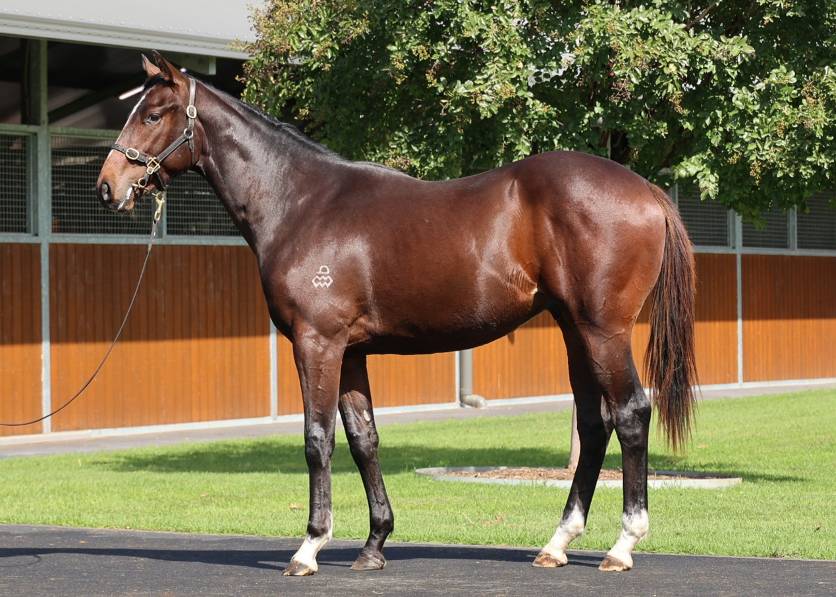
EMAIL ENQUIRIES@JOSEPHJONESRACING.COM.AU
OR PHONE PAUL ON 0414 811 561

