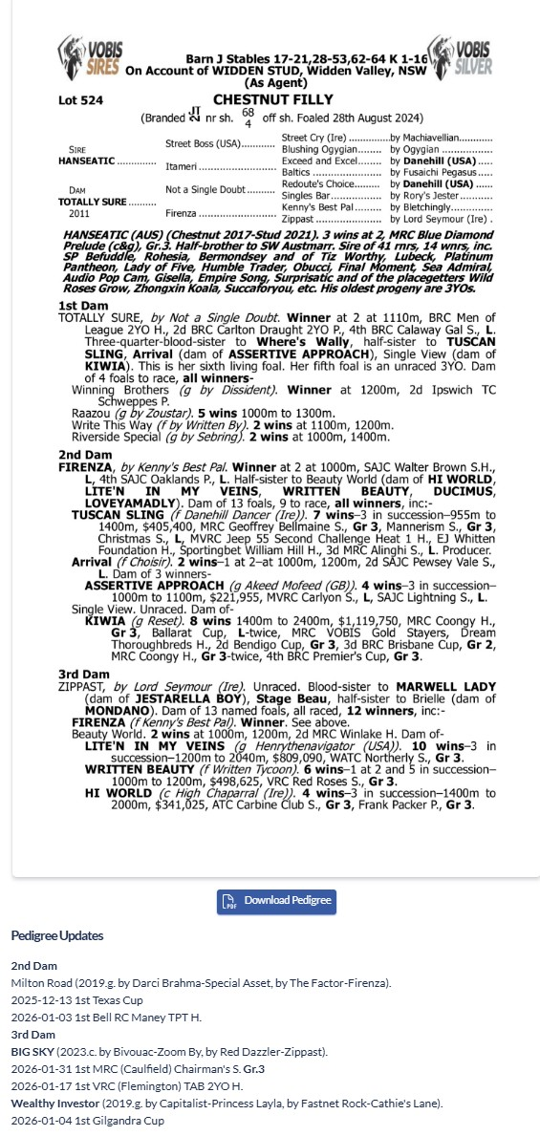

HANSEATIC X TOTALLY SURE 1YO FILLY
- 5% SHARE IS $1,417 FEES START 1/6/26 -70% AVAILABLE.
- By HANSEATIC who was the winner GROUP 3 BLUE DIAMOND PRELUDE.
- DAM TOTALLY SURE got 100% strike rate, had 4 foals to race for 4 winners.
- The 3 Dams on the pedigree page have had 22 individual winners at 96% SR
- 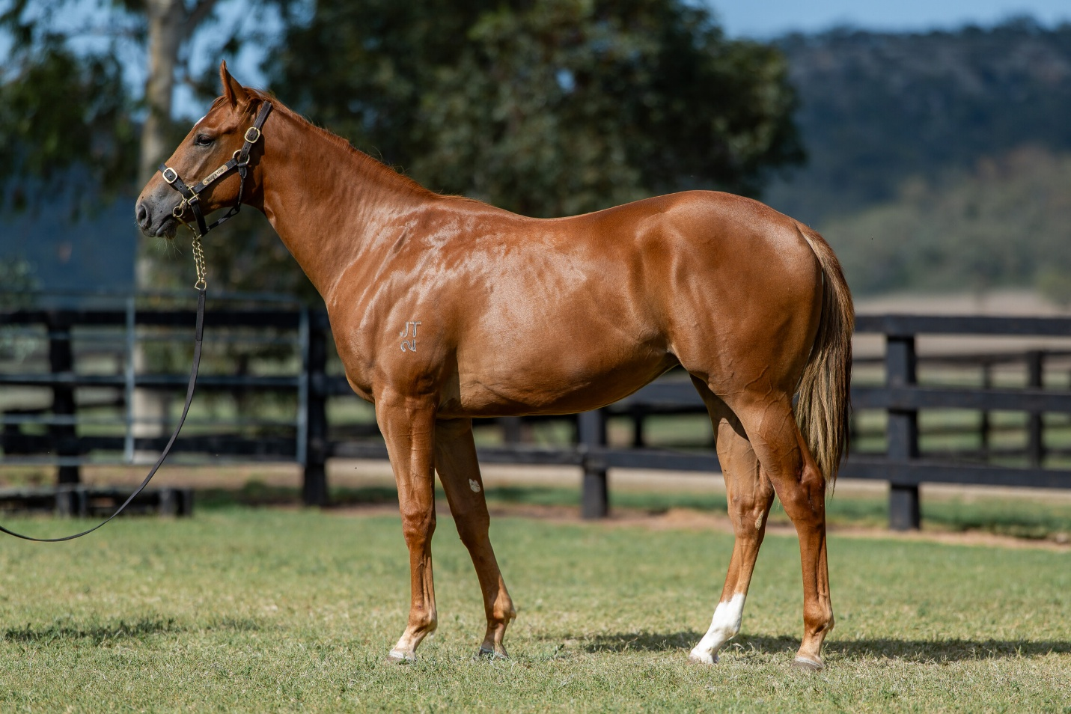
EMAIL ENQUIRIES@JOSEPHJONESRACING.COM.AU
OR PHONE PAUL ON 0414 811 561

