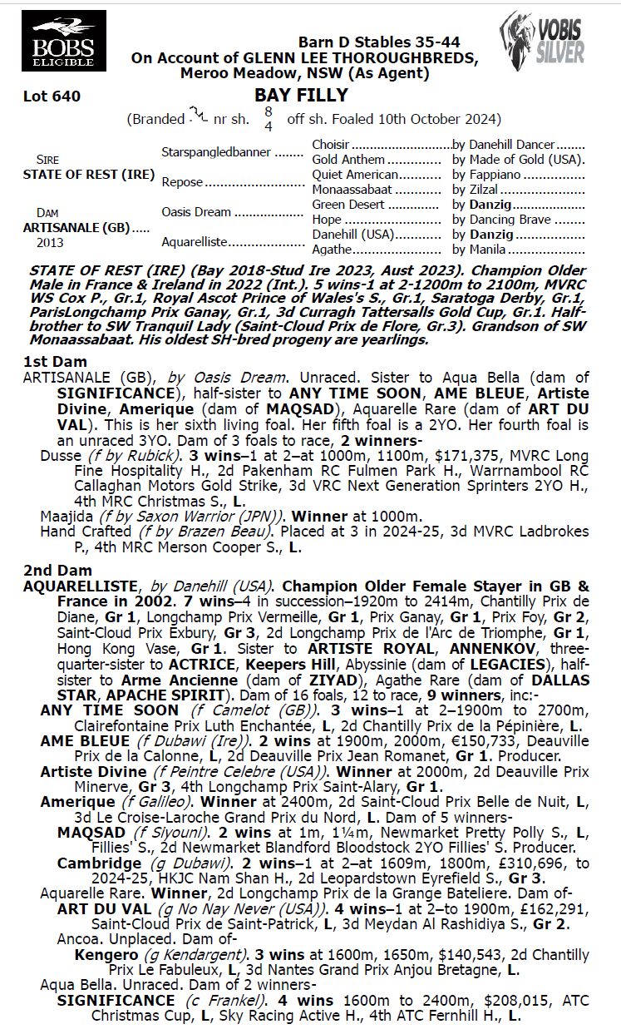
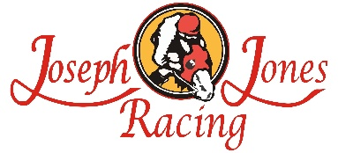
STATE OF REST X ARTISANALE 1YO FILLY
- 5% SHARE IS $1,879 FEES START 1/6/26 -70% AVAILABLE.
- By First Season Sire STATE OF REST a 4 x GROUP 1 Winner inc MVRC COX PLATE beating Australian Champions ANAMOE & VERRY ELEEGANT.
- 1/2 sister to Dusse 3 time winner & ran close up 4th in Listed MRC Xmas Stks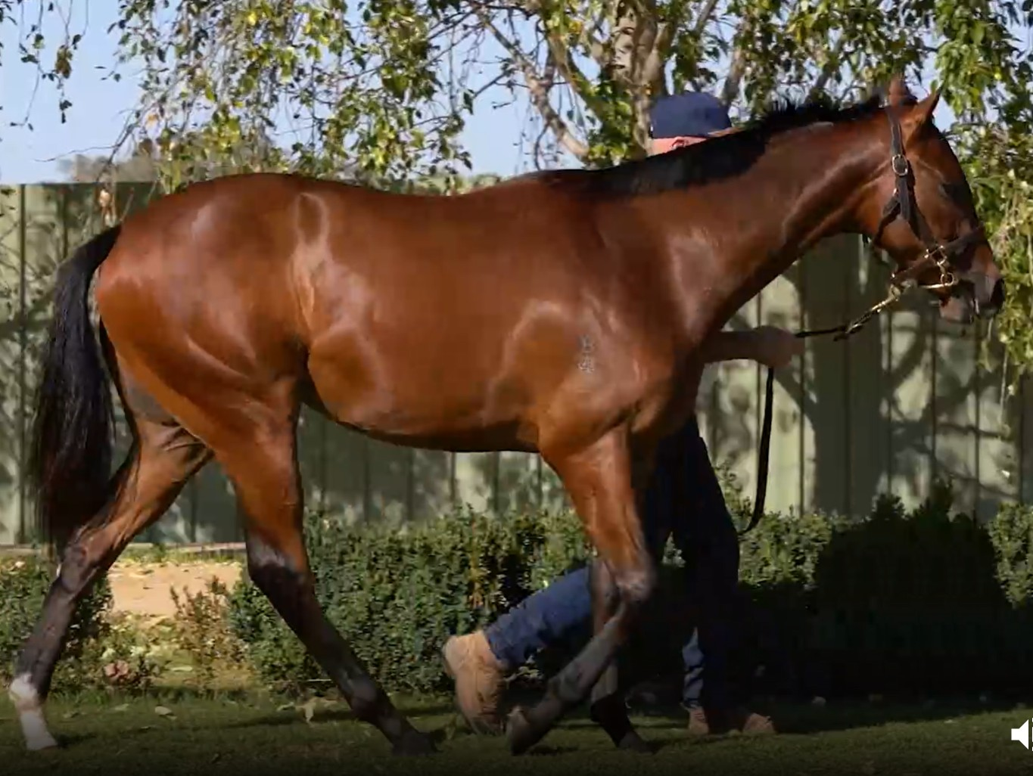
EMAIL ENQUIRIES@JOSEPHJONESRACING.COM.AU
OR PHONE PAUL ON 0414 811 561

