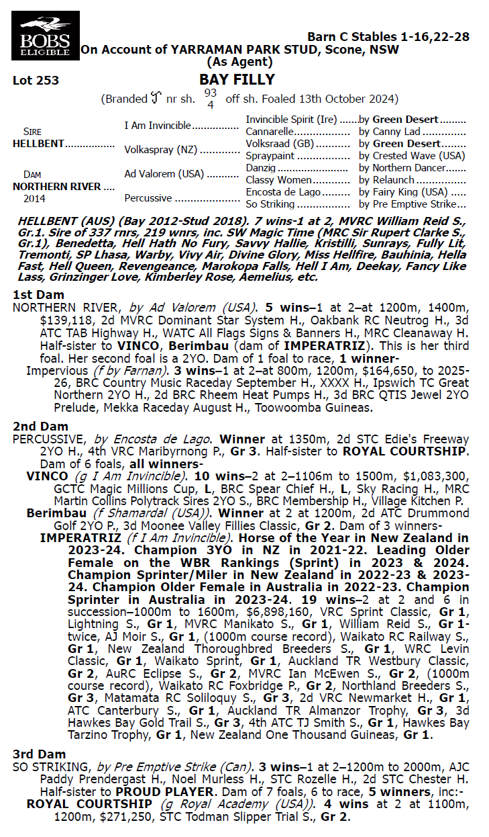

HELLBENT x NORTHERN RIVER 1YO FILLy
- 5% SHARE IS $3,372 FEES START 1/6/26 - 65% AVAILABLE.
- HELLBENT HAS A 67.5% WINNERS TO RUNNERS RATIO.
- Closely related to 9 time Group 1 Champion NZ mare IMPERATRIX (19 Wins).
- ½ sister to Impervious already a metro winner 9s-3w-4p & $168k prizemoney.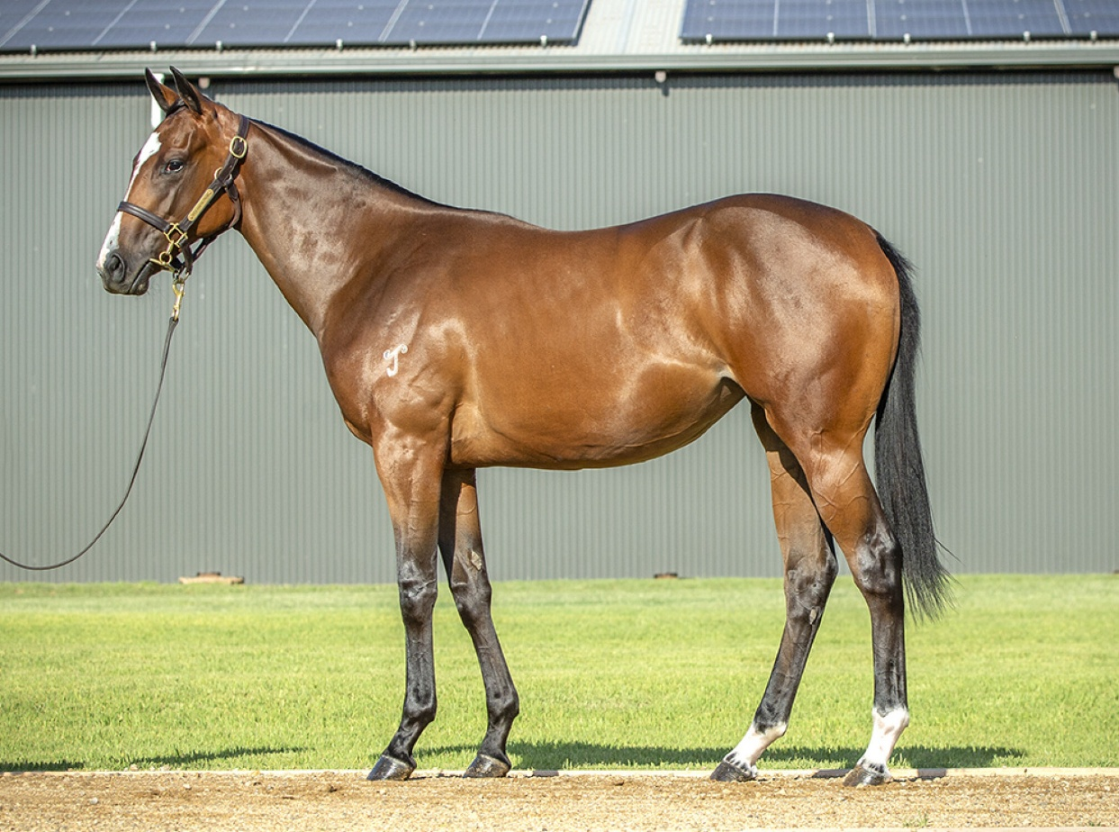
EMAIL ENQUIRIES@JOSEPHJONESRACING.COM.AU
OR PHONE PAUL ON 0414 811 561

