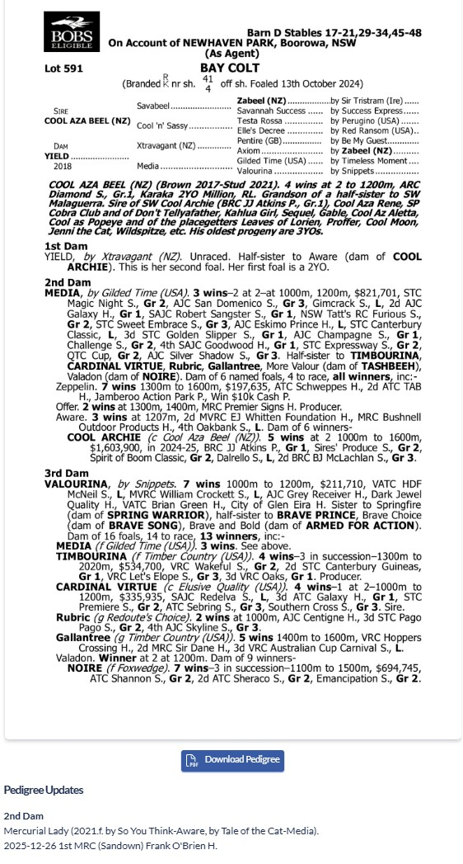
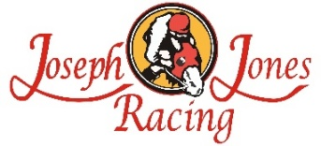
COOL AZA BEEL x YIELD SURE 1YO GELDING
- 5% SHARE IS $3,553 FEES START 1/4/26 -70% AVAILABLE.
- By COOL AZA BEEL was the winner GRP 1 ARC DIAMOND & Karaka Millions
- Our gelding is closely related to COOL ARCHIE winner of GRP 1 JJ ATKINS.
- Bred on the same cross as NZ GROUP Winner COOL AZA RENE
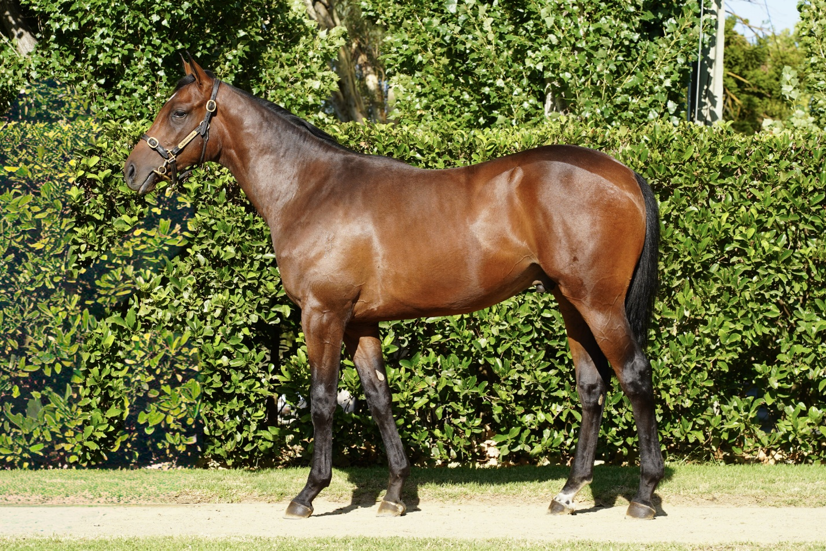
EMAIL ENQUIRIES@JOSEPHJONESRACING.COM.AU
OR PHONE PAUL ON 0414 811 561

