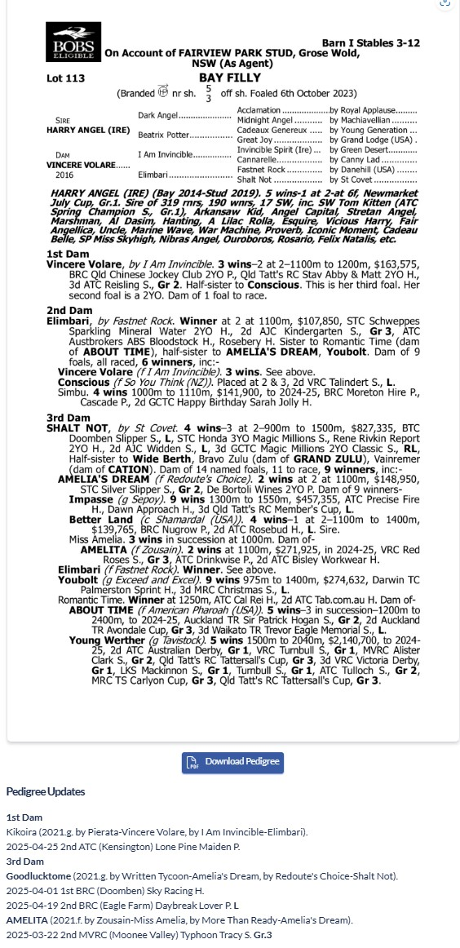

HARRY ANGEL X VINCERE VOLARE 1YO FILLY
- 5% SHARE IS $1,153 FEES START 1/1/26 5% shares AVAILABLE.
- BY PROGRESSIVE SIRE HARRY ANGEL SIRE OF Tom Kitten, Private Harry.
- HARRY is 60% Runners to Winners and 10% Stake Winners to Winners.
- ½ brother Kikoira trained by Chris Waller placed Sydney 25/4/25
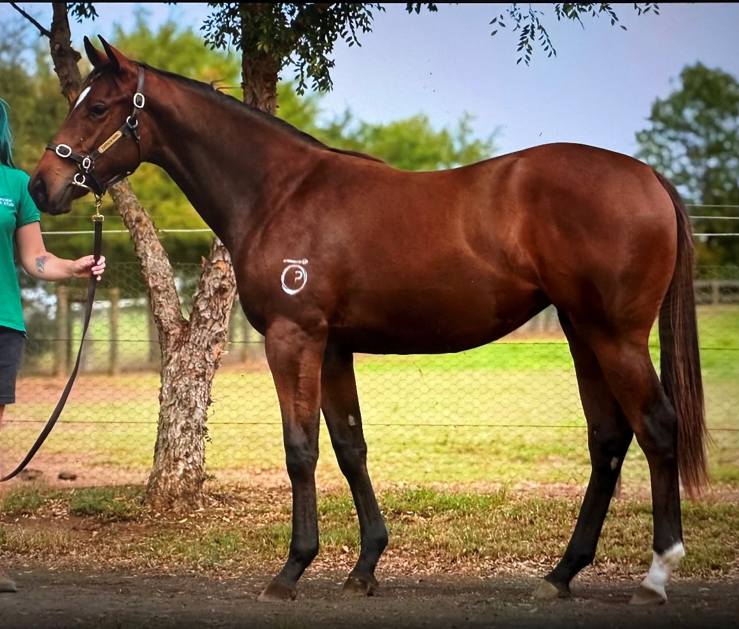
EMAIL ENQUIRIES@JOSEPHJONESRACING.COM.AU
OR PHONE PAUL ON 0414 811 561

