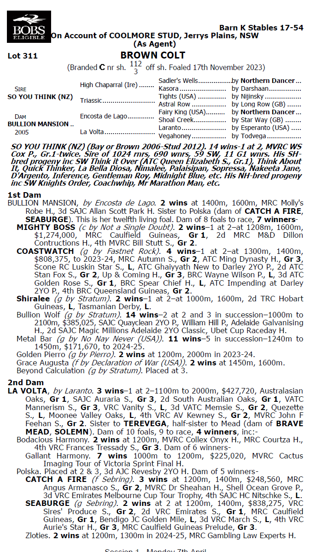

**SO YOU THINK X BULLION MANSION 1YO GELDING**

* **5% SHARE IS $4,334 FEES START 1/6/25 5% shares AVAILABLE.**
* **½ BROTHER TO GROUP WINNERS MIGHTY BOSS & COASTWATCH.**
* **So You Think 70% Runner to Winners and 10% Stake Winner to Winners.**
* **Bought at Inglis Easter Sales and is cracking 3yo Staying type**

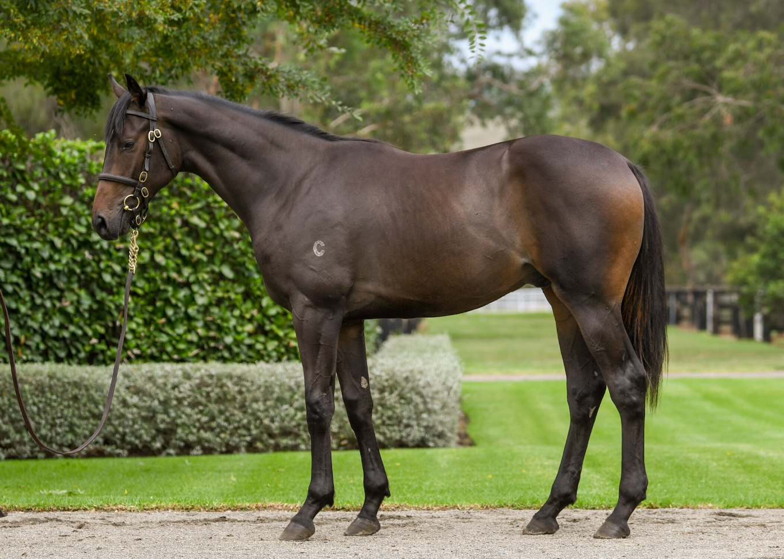

EMAIL ENQUIRIES@JOSEPHJONESRACING.COM.AU

OR PHONE PAUL ON 0414 811 561