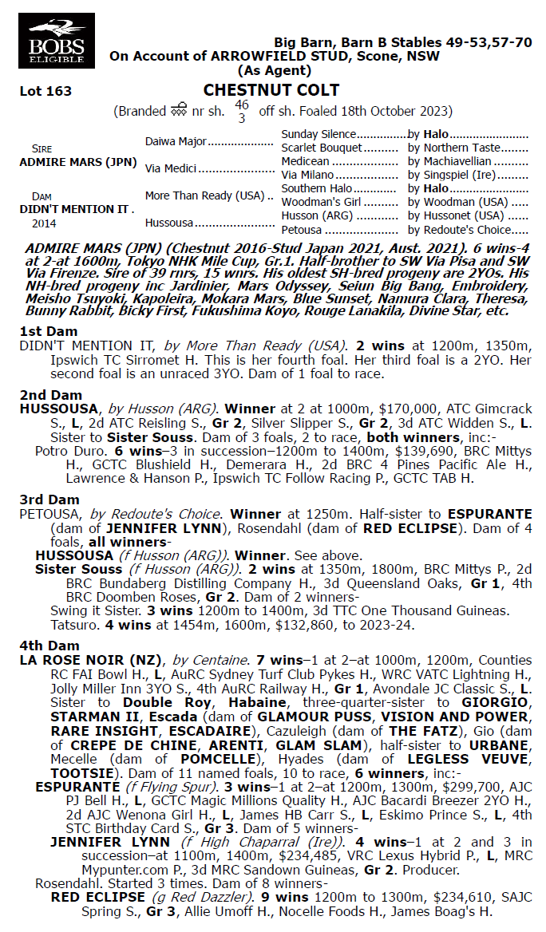

**ADMIRE MARS X DIDN’T MENTION IT 1YO GELDING**

* **5% SHARE IS $2,297 FEES START 1/4/25 70% AVAILABLE.**
* **BY CHAMPION JAPANESE RACEHORSE ADMIRE MARS. 19 WINNERS IN JAPAN IN HIS FIRST CROP OF 2YO’s inc SW JARDINIER.**
* **½ BROTHER PROUD MENTION SYD TRIAL WINNER 3/1/25 SOLD TO HK.**

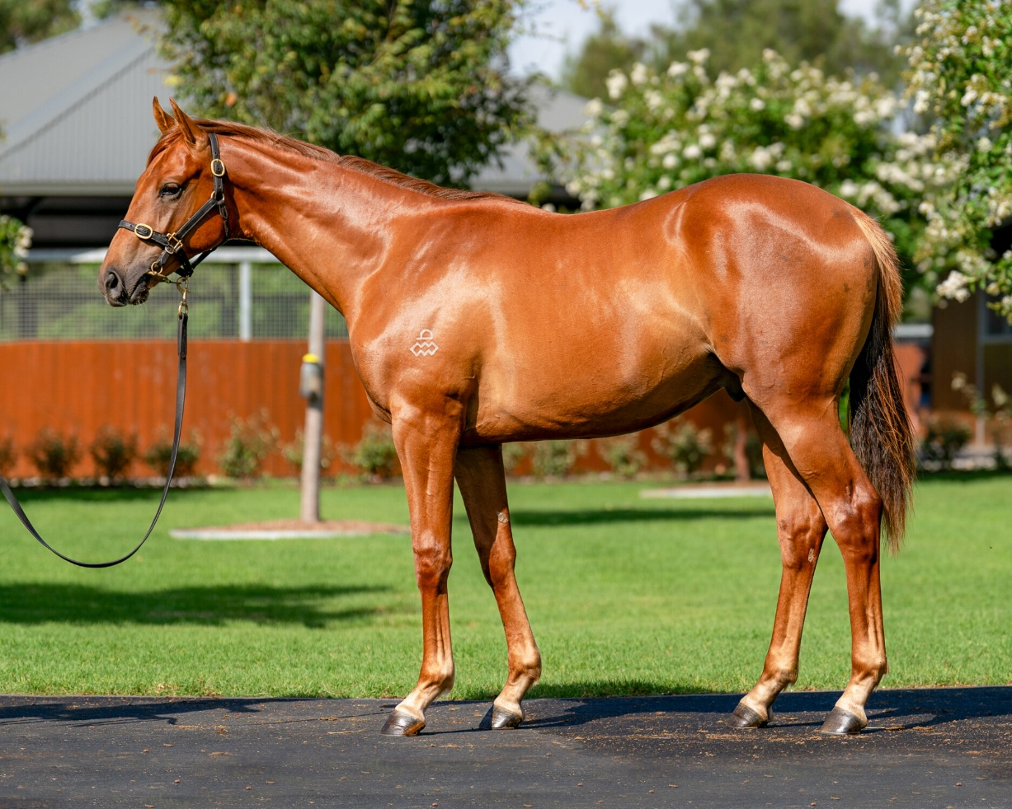

EMAIL ENQUIRIES@JOSEPHJONESRACING.COM.AU

OR PHONE PAUL ON 0414 811 561