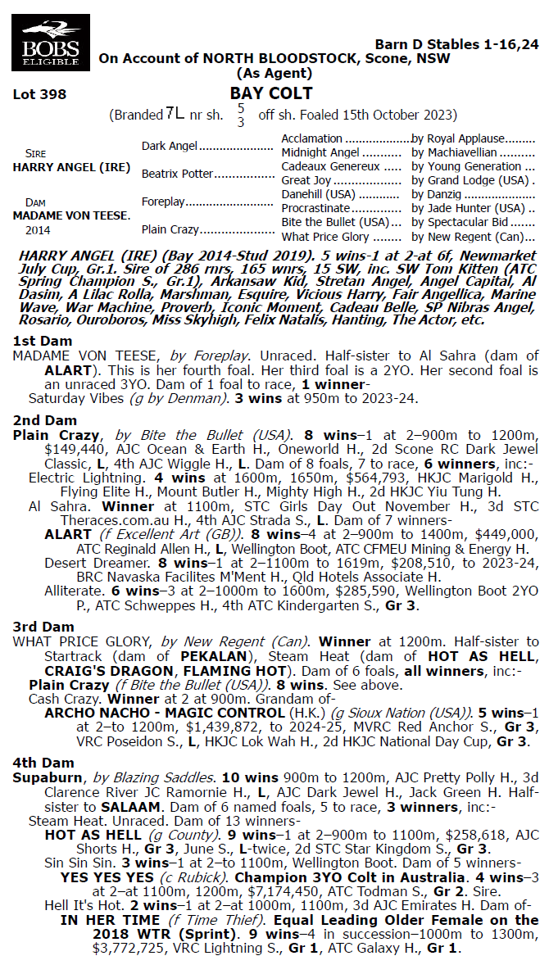

**HARRY ANGEL X MADAME VON TEESE 1YO GELDING**

* **5% SHARE IS $1,746 FEES START 1/4/25 5% shares AVAILABLE.**
* **BY PROGRESSIVE SIRE HARRY ANGEL SIRE OF Tom Kitten, Private Harry.**
* **HARRY is 60% Runners to Winners and 10% Stake Winners to Winners.**
* **DAM MADAME VON TEESE Dam of Saturday Vibes who’s 5 time Winner**

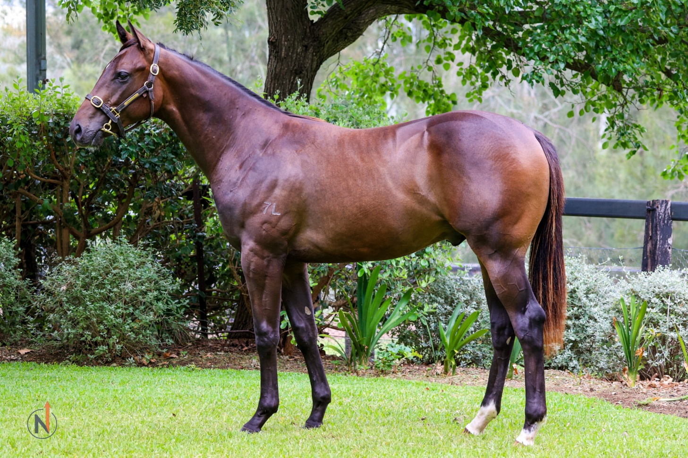

EMAIL ENQUIRIES@JOSEPHJONESRACING.COM.AU

OR PHONE PAUL ON 0414 811 561