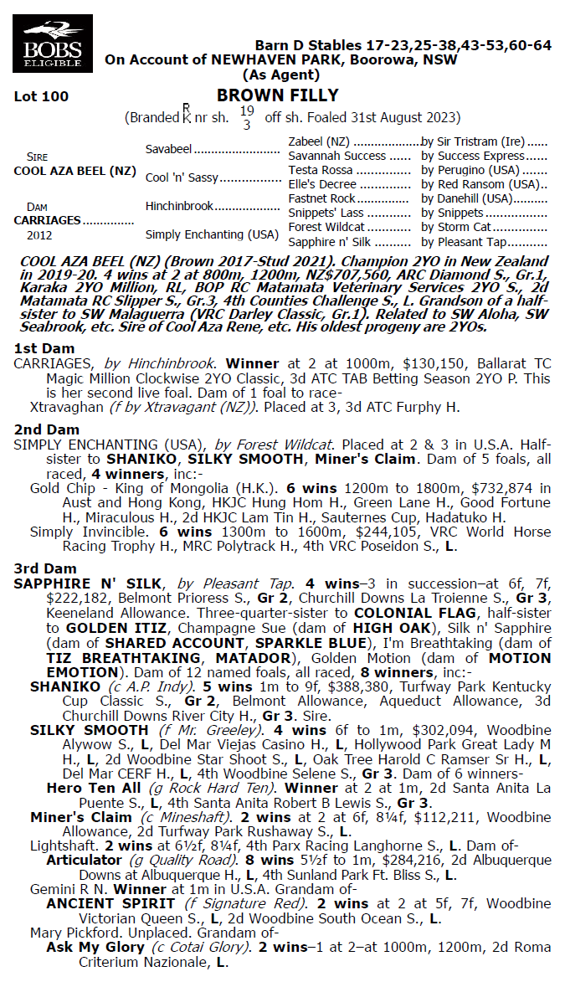

**COOL AZA BEEL x CARRIAGES 1YO FILLY**

* **5% SHARE IS $2,610 FEES START 1/1/26 70% AVAILABLE.**
* **BY COOL AZA BEEL GRP 1 WINNER & CHAMPION 2YO IN NEW ZEALAND.**
* **AIMED AT PINK LADIES BONUS 75% OF OWNERSHIP TO BE LADIES.**
* **PAID UP FOR THE RICH INGLIS RACE SERIES inc 100k Maiden Bonuses.**

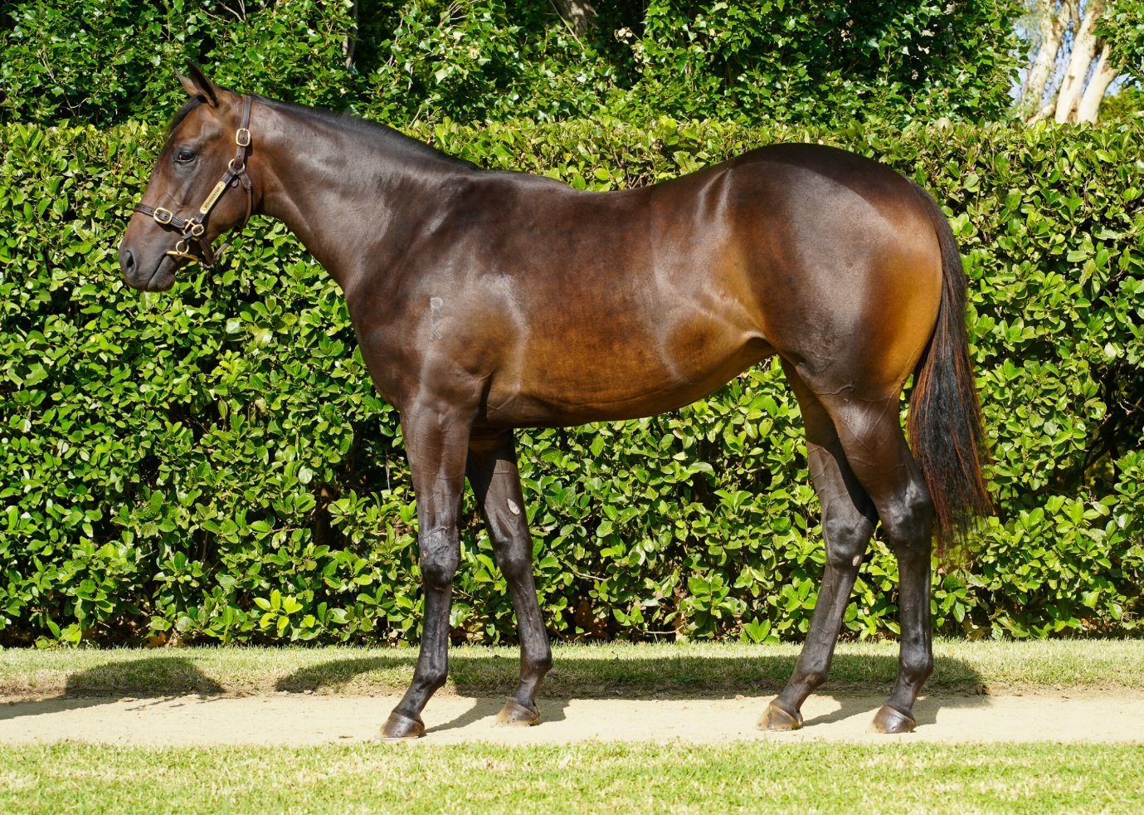

EMAIL ENQUIRIES@JOSEPHJONESRACING.COM.AU

OR PHONE PAUL ON 0414 811 561